- Iteratively inserting each element of unsorted list in its correct position in a sorted portion
  - Like playing cards and sorting them into your hands
  - You split the cards into two groups
    - The sorted cards and the unsorted cards
    - Then you pick a card from the unsorted group and put it in the right place in the sorted group
  - Start with the second element as the first element is assumed to be sorted
  - Compare the second element with the first if the second is smaller then swap them.
  - Move to the third element, compare it with the 1st two and put it in its correct position
  - Repeat until the entire array is sorted

12 | 11 | 13 | 5 | 6

- They key is the number you are currently trying to place in its correct spot
  - At first the 12 is sorted since it is the first element
  - And at first too the key is 11
  - So we are trying to put the key in its correct position
- 1st pass
  - We compare the key which is 11 to 12 if 11 is less than 12 then 12 moves to the right to fill the place of the key which is 11 and 11 will take its place

11 | 12 | 13 | 5 | 6
- 2nd pass ( right now 11 and 12 are sorted and 13 and 5 and 6 are unsorted)

11 | 12 | 13 | 5 | 6
- The key is 13 currently
  - We compare 13 to 12 and 13 is bigger than 12 so no changes will happen the key is in its correct place
3rd pass (right now 11, 12, 12 are sorted 5 and 6 are unsorted)
- The key is 5 currently
- We will compare 5 against 13 and 5 is lesser than 13
- So 13 will take the place of 5 then 5 will take the place of 13

11 | 12 | 5 | 13 | 6
- Then we compare again 5 against 12 and 5 is lesser than 12 so they switch places

11 | 5 | 12 | 13 | 6
- Then we compare again 5 against 11 5 is lesser than 11 11 takes the place of 5 and 5 takes the place of 11

5 | 11 | 12 | 13 | 6

- 4th pass (5,11,12,13 are sorted while 6 isnt sorted
We will do what we did before shifting stuff

5 | 6 | 11 | 12 | 13

All are sorted and 5<6<11<12<13.

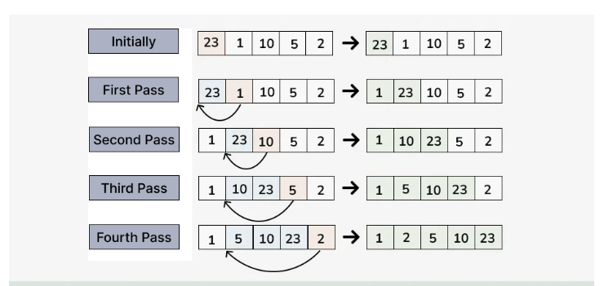

void insertionSort(int arr[], int n)
{
for (int i = 1; i < n; ++i) {
int key = arr[i];
int j = i - 1;
We start by assigning the key to array[1] so the key becomes number 11
And then we just setup the j to look back before the key which will be needed in the while loop
In order to determine where to put the key
( the j we are starting with is 0 1-1

/* Move elements of arr[0..i-1], that are
greater than key, to one position ahead
of their current position */
(while j is greater than 0 and arr[j] is greater than key)
(if the j which is zero which is the beginning selection is greater than the key which is the one that follows it then we should change its location to be one stop ahead to take the key’s place)
while (j >= 0 && arr[j] > key) {
(if arr[0+1]=arr[0] meaning put the 1st array in the 2nd array if its bigger)
arr[j + 1] = arr[j];)
(then we put the j=j-1 because we want to check back again the numbers with while loop, if we meet a number that is smaller than the current k the while loop will break)
j = j - 1;
}
arr[j + 1] = key;
(after the while loop breaks we will put the key one step back)
}
}

/* A utility function to print array of size n */
void printArray(int arr[], int n)
{
for (int i = 0; i < n; ++i)
cout << arr[i] << " ";
cout << endl;
}

// Driver method
int main()
{
int arr[] = { 12, 11, 13, 5, 6 };
int n = sizeof(arr) / sizeof(arr[0]);

insertionSort(arr, n);
printArray(arr, n);

return 0;
}

